7. You have a Cisco switch and a VoIP phone that needs to be placed in a voice VLAN (VLAN 20). The data for the PC should remain in a separate VLAN (VLAN 10). Configure the switch port to support both voice and data traffic.
To configure a Cisco switch port so that:
- VoIP Phone traffic goes through Voice VLAN 20
- PC traffic goes through Data VLAN 10

Devices Used
- 1 Cisco 2960 Switch
- 1 IP Phone
- 1 PC
- Copper Straight-Through cables

Network Topology
In this experiment:
- The PC is connected to the IP Phone
- The IP Phone is connected to the Switch
This setup allows both voice traffic and data traffic to pass through the same switch port.

Procedure

Step 1: Open Cisco Packet Tracer
Cisco Packet Tracer was opened to create the required network topology.

Step 2: Place the devices
The following devices were placed in the workspace:
- One 2960 Switch
- One IP Phone
- One PCStep 3:

Connect the devices
The devices were connected using Copper Straight-Through cables.

The connections were made as follows:
- PC → IP Phone
- IP Phone → Switch (FastEthernet0/1)
This allows the PC to send data traffic through the phone, while the phone carries voice traffic.
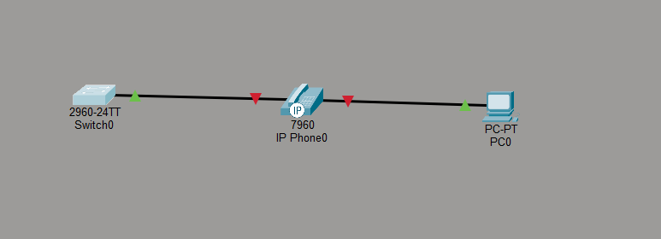

Step 4: Open the Switch CLI
The switch was opened and the CLI tab was selected to enter the configuration commands.

Step 5: Enter privileged mode
The following command was entered to move to privileged EXEC mode:
enable

Step 6: Enter global configuration mode
The following command was entered:
configure terminal
This allows VLAN and interface configuration.

Step 7: Create Data VLAN 10
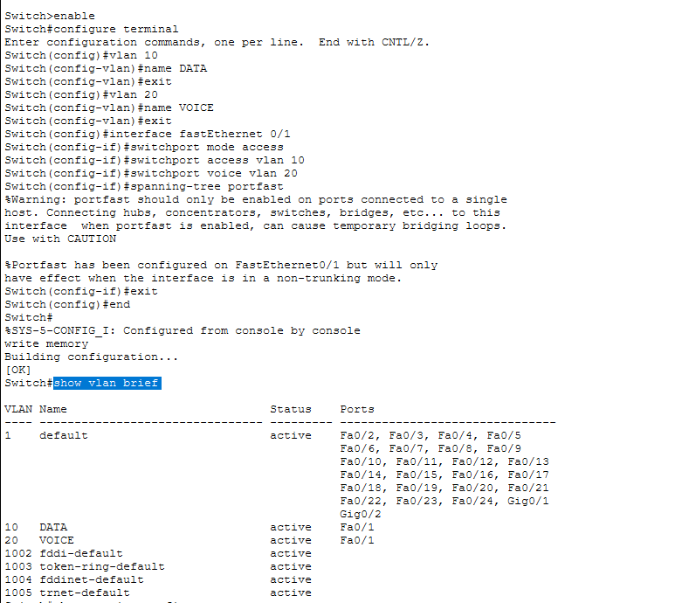
The following commands were entered to create VLAN 10 for data traffic:
vlan 10
name DATA
exit

Explanation:
- vlan 10 creates VLAN number 10
- name DATA gives the name DATA to VLAN 10

Step 8: Create Voice VLAN 20
The following commands were entered to create VLAN 20 for voice traffic:
vlan 20
name VOICE
exit

Explanation:
- vlan 20 creates VLAN number 20
- name VOICE gives the name VOICE to VLAN 20

Step 9: Configure the switch port connected to the IP Phone
Since the IP Phone was connected to FastEthernet0/1, that port was configured using the following commands:
interface fastEthernet 0/1
switchport mode access
switchport access vlan 10
switchport voice vlan 20
spanning-tree portfast
exit

Explanation:
- interface fastEthernet 0/1 selects the port connected to the IP Phone
- switchport mode access makes the port an access port
- switchport access vlan 10 assigns data traffic to VLAN 10
- switchport voice vlan 20 assigns voice traffic to VLAN 20
- spanning-tree portfast enables faster port activation for end devices

Step 10: Exit and save the configuration
After configuration, the following commands were used:
end
write memory

Explanation:
- end exits configuration mode
- write memory saves the configuration permanently

Commands Used
The complete switch configuration used in this experiment is given below:
enable
configure terminal

vlan 10
name DATA
exit

vlan 20
name VOICE
exit

interface fastEthernet 0/1
switchport mode access
switchport access vlan 10
switchport voice vlan 20
spanning-tree portfast
exit

end
write memory

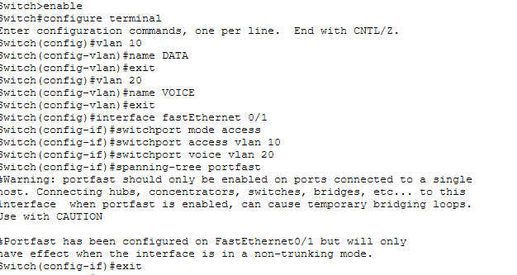

Verification

Step 11: Verify VLAN creation
The following command was entered:
show vlan brief

Observation:
The output showed:
- VLAN 10 named DATA
- VLAN 20 named VOICE
- FastEthernet0/1 associated with the configured VLANs
This confirms that the VLANs were created successfully.


Step 12: Verify interface configuration
The following command was entered:
show running-config

Observation:
The output showed the configuration under FastEthernet0/1, including:
- switchport access vlan 10
- switchport voice vlan 20
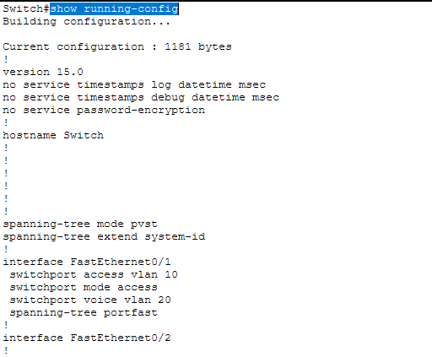
This confirms that the port was configured correctly for both data and voice traffic.

Output / Result
The switch was successfully configured so that:
- The PC traffic uses Data VLAN 10
- The IP Phone traffic uses Voice VLAN 20
- Both devices communicate through the same physical switch port
Thus, the Voice VLAN and Data VLAN configuration was completed successfully in Cisco Packet Tracer.

9. Configure Dynamic NAT on a router to allow hosts from the private network 192.168.1.0/24 to access an external network using a pool of public IP addresses from 209.165.200.226 to 209.165.200.240.
To configure Dynamic NAT on a Cisco router so that devices in the private network 192.168.1.0/24 can access an external network using a pool of public IP addresses.

Devices Used
- 1 Router
- 1 Switch
- 2 PCs
- 1 Server
- Copper Straight-Through cables

Network Topology
In this experiment:
- Two PCs were connected to a switch
- The switch was connected to a router
- The router was connected to a server representing the external network
This setup was used to demonstrate Dynamic NAT translation.

IP Addressing Table
Device | Interface | IP Address | Subnet Mask | Default Gateway
Router | G0/0 | 192.168.1.1 | 255.255.255.0 | —
Router | G0/1 | 209.165.200.225 | 255.255.255.224 | —
PC0 | NIC | 192.168.1.10 | 255.255.255.0 | 192.168.1.1
PC1 | NIC | 192.168.1.11 | 255.255.255.0 | 192.168.1.1
Server | NIC | 209.165.200.241 | 255.255.255.224 | 209.165.200.225

Procedure

Step 1: Open Cisco Packet Tracer
Cisco Packet Tracer was opened to build the required network topology.

Step 2: Place the devices
The following devices were placed in the workspace:
- One Router
- One Switch
- Two PCs
- One Server

Step 3: Connect the devices
The devices were connected using Copper Straight-Through cables.

The connections were made as follows:
- PC0 → Switch
- PC1 → Switch
- Switch → Router (G0/0)
- Router (G0/1) → Server
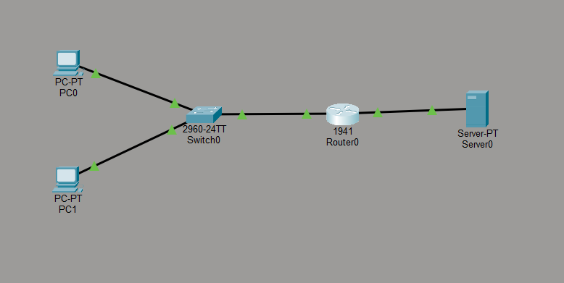
This created an inside network and an outside network.

Step 4: Configure IP address on PC0
The IP settings for PC0 were configured as follows:
- IP Address: 192.168.1.10
- Subnet Mask: 255.255.255.0
- Default Gateway: 192.168.1.1

Step 5: Configure IP address on PC1
The IP settings for PC1 were configured as follows:
- IP Address: 192.168.1.11
- Subnet Mask: 255.255.255.0
- Default Gateway: 192.168.1.1

Step 6: Configure IP address on Server
The IP settings for the Server were configured as follows:
- IP Address: 209.165.200.241
- Subnet Mask: 255.255.255.224
- Default Gateway: 209.165.200.225

Step 7: Configure the inside interface
The router interface connected to the switch was configured as the inside interface using the following commands:
interface gigabitEthernet 0/0
ip address 192.168.1.1 255.255.255.0
no shutdown
exit

Explanation:
- gigabitEthernet 0/0 is connected to the internal LAN
- 192.168.1.1 acts as the default gateway for internal PCs

Step 8: Configure the outside interface
The router interface connected to the server was configured as the outside interface using the following commands:
interface gigabitEthernet 0/1
ip address 209.165.200.225 255.255.255.224
no shutdown
exit

Explanation:
- gigabitEthernet 0/1 connects to the external network
- 209.165.200.225 is the router’s public-side interface

Step 9: Create an access list for the private network
The following command was used to identify the private LAN that should be translated by NAT:
access-list 1 permit 192.168.1.0 0.0.0.255

Explanation:
This access list permits all hosts in the 192.168.1.0/24 network to use NAT.

Step 10: Create the Dynamic NAT pool
The following command was used to create the pool of public IP addresses:
ip nat pool MYPOOL 209.165.200.226 209.165.200.240 netmask 255.255.255.224

Explanation:
This creates a pool of public IP addresses ranging from:
- 209.165.200.226
to
- 209.165.200.240
These addresses will be used to translate private IP addresses dynamically.

Step 11: Bind the access list to the NAT pool
The following command was used:
ip nat inside source list 1 pool MYPOOL

Explanation:
This command tells the router to translate all inside private addresses matched by Access List 1 using the MYPOOL public IP range.

Step 12: Mark the interfaces as NAT inside and outside
The following commands were entered:
interface gigabitEthernet 0/0
ip nat inside
exit

interface gigabitEthernet 0/1
ip nat outside
exit

Explanation:
- ip nat inside marks the internal/private interface
- ip nat outside marks the external/public interface
This step is essential for NAT to function properly.

Step 13: Save the configuration
After completing the router configuration, the following commands were used:
end
write memory

Explanation:
- end exits configuration mode
- write memory saves the configuration permanently

Commands Used
The complete router configuration used in this experiment is given below:
enable
configure terminal

interface gigabitEthernet 0/0
ip address 192.168.1.1 255.255.255.0
no shutdown
exit

interface gigabitEthernet 0/1
ip address 209.165.200.225 255.255.255.224
no shutdown
exit

access-list 1 permit 192.168.1.0 0.0.0.255

ip nat pool MYPOOL 209.165.200.226 209.165.200.240 netmask 255.255.255.224

ip nat inside source list 1 pool MYPOOL

interface gigabitEthernet 0/0
ip nat inside
exit

interface gigabitEthernet 0/1
ip nat outside
exit

end
write memory

Verification

Step 17: Test connectivity using ping
From the PC command prompt, the following command was used:
ping 209.165.200.241

Observation:
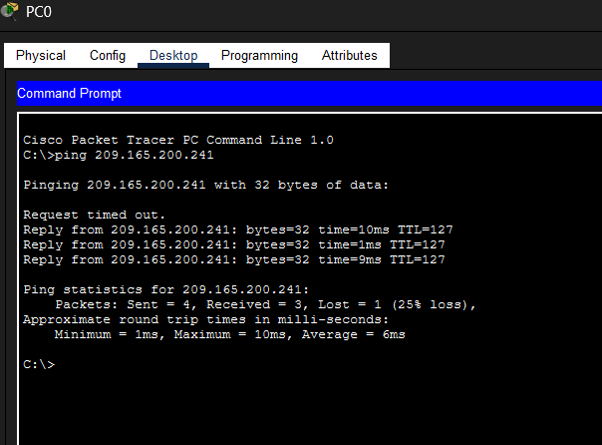
The ping was successful, proving that the private network was able to communicate with the external server.

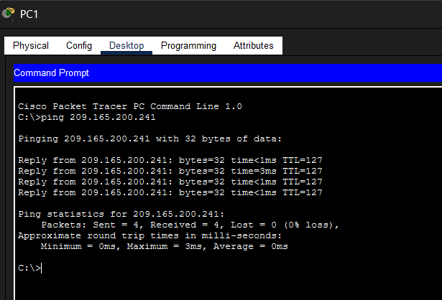

Step 18: Verify NAT translation
The following command was entered on the router:
show ip nat translations

Observation:
The output showed that the private IP address was translated into a public IP address from the NAT pool.
Example:
- Inside Local: 192.168.1.11
- Inside Global: 209.165.200.227
This confirms that Dynamic NAT was functioning correctly.

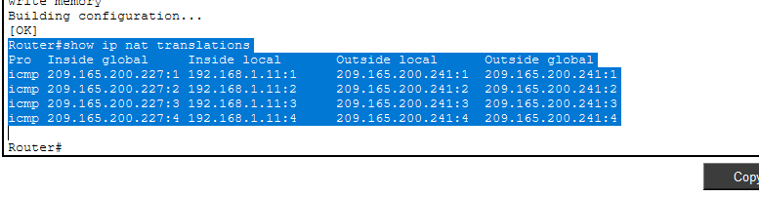
10. Configure a Standard ACL to block traffic from 192.168.1.0/24 to a server at 10.0.0.100, but allow traffic to other destinations.
To configure a Standard Access Control List (ACL) on a Cisco router to block traffic from the network 192.168.1.0/24 to the destination network, and verify the ACL configuration in Cisco Packet Tracer.

Devices Used
- 1 Router
- 2 Switches
- 3 PCs
- 1 Server
- Copper Straight-Through cables

Network Topology
In this experiment:
- Two PCs were placed in the source network
- One server and one additional PC were placed in the destination network
- The source and destination networks were connected through a router
This setup was used to demonstrate Standard ACL configuration.

IP Addressing Table
Device |  | IP Address | Subnet Mask | Default Gateway
Router |  | 192.168.1.1 | 255.255.255.0 | —
Router |  | 10.0.0.1 | 255.255.255.0 | —
PC0 |  | 192.168.1.10 | 255.255.255.0 | 192.168.1.1
PC1 |  | 192.168.1.11 | 255.255.255.0 | 192.168.1.1
Server |  | 10.0.0.100 | 255.255.255.0 | 10.0.0.1
PC2 |  | 10.0.0.50 | 255.255.255.0 | 10.0.0.1

Procedure

Step 1: Open Cisco Packet Tracer
Cisco Packet Tracer was opened to create the required network topology.

Step 2: Place the devices
The following devices were placed in the workspace:
- One Router
- Two Switches
- Three PCs
- One Server
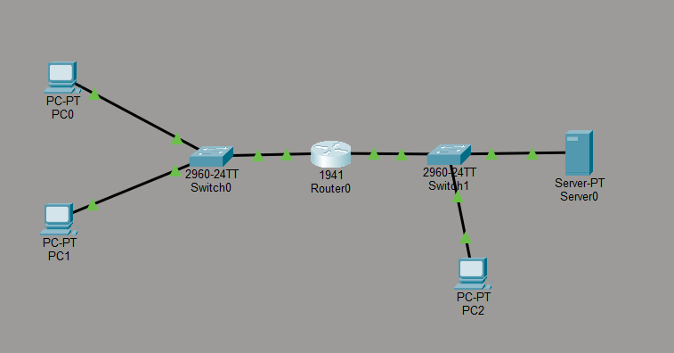

Step 3: Connect the devices
The devices were connected using Copper Straight-Through cables.

The connections were made as follows:
- PC0 → Switch0
- PC1 → Switch0
- Switch0 → Router (G0/0)
- Router (G0/1) → Switch1
- Switch1 → Server
- Switch1 → PC2
This created a source network and a destination network.

Step 4: Configure IP address on PC0
The IP settings for PC0 were configured as follows:
- IP Address: 192.168.1.10
- Subnet Mask: 255.255.255.0
- Default Gateway: 192.168.1.1

Step 5: Configure IP address on PC1
The IP settings for PC1 were configured as follows:
- IP Address: 192.168.1.11
- Subnet Mask: 255.255.255.0
- Default Gateway: 192.168.1.1

Step 6: Configure IP address on Server
The IP settings for the Server were configured as follows:
- IP Address: 10.0.0.100
- Subnet Mask: 255.255.255.0
- Default Gateway: 10.0.0.1

Step 7: Configure IP address on PC2
The IP settings for PC2 were configured as follows:
- IP Address: 10.0.0.50
- Subnet Mask: 255.255.255.0
- Default Gateway: 10.0.0.1

Step 8: Configure the router interface for the source network
The router interface connected to the source network was configured using the following commands:
interface gigabitEthernet 0/0
ip address 192.168.1.1 255.255.255.0
no shutdown
exit

Explanation:
- gigabitEthernet 0/0 is connected to the source network
- 192.168.1.1 acts as the default gateway for PC0 and PC1

Step 9: Configure the router interface for the destination network
The router interface connected to the destination network was configured using the following commands:
interface gigabitEthernet 0/1
ip address 10.0.0.1 255.255.255.0
no shutdown
exit

Explanation:
- gigabitEthernet 0/1 is connected to the destination network
- 10.0.0.1 acts as the default gateway for the Server and PC2

Step 10: Test connectivity before applying ACL
Before applying the ACL, connectivity was tested using the ping command to ensure that routing between the networks was working correctly.
Example:
ping 10.0.0.100
This confirmed that the source PC could reach the destination network before ACL configuration.

Step 11: Create the Standard ACL
The following commands were entered to create a Standard ACL:
access-list 1 deny 192.168.1.0 0.0.0.255
access-list 1 permit any

Explanation:
- deny 192.168.1.0 0.0.0.255 blocks traffic from the source network
- permit any allows all other traffic

Step 12: Apply the ACL to the router interface
The Standard ACL was applied on the destination-side interface using the following commands:
interface gigabitEthernet 0/1
ip access-group 1 out
exit

Explanation:
- The ACL was applied on the outgoing direction of the destination interface
- This ensures that traffic from the source network is filtered before reaching the destination network

Step 13: Save the configuration
After completing the configuration, the following commands were used:
end
write memory

Explanation:
- end exits configuration mode
- write memory saves the configuration permanently

Commands Used
The complete router configuration used in this experiment is given below:
enable
configure terminal

interface gigabitEthernet 0/0
ip address 192.168.1.1 255.255.255.0
no shutdown
exit

interface gigabitEthernet 0/1
ip address 10.0.0.1 255.255.255.0
no shutdown
exit

access-list 1 deny 192.168.1.0 0.0.0.255
access-list 1 permit any

interface gigabitEthernet 0/1
ip access-group 1 out
exit

end
write memory

Verification

Before ACL
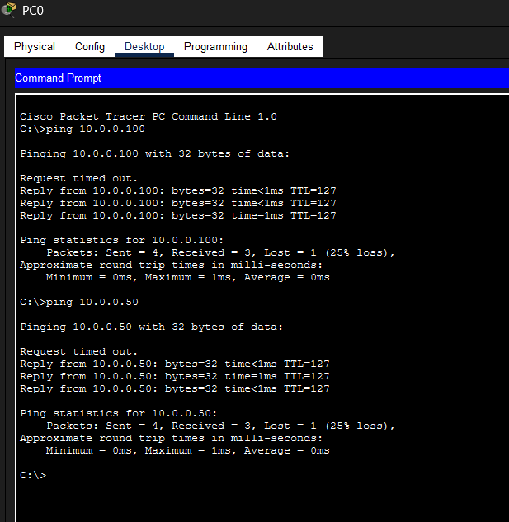

Step 17: Verify connectivity after ACL configuration
After applying the ACL, the following command was used from the source PC:
ping 10.0.0.100

Observation:
The ping request was blocked, confirming that the Standard ACL was functioning.
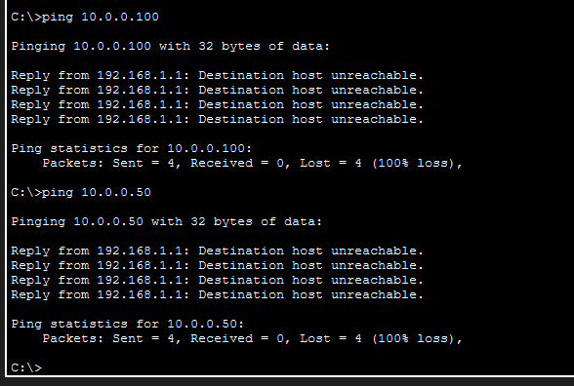

Step 18: Verify ACL entries
The following command was entered on the router:
show access-lists

Observation:
The output displayed the ACL entries created on the router.
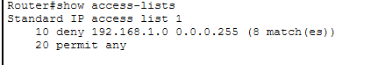

Step 19: Verify ACL application on the interface
The following command was entered:
show running-config

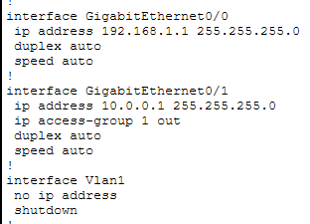

Observation:
The output showed that ACL 1 was applied on GigabitEthernet0/1 in the outgoing direction.
11. Configure port security on a switch port so that only one MAC address is allowed. If another device connects, the port should shut down.

Devices Used
- 1 Cisco 2960 Switch
- 2 PCs (PC0, PC1)
- Copper Straight-Through cable

Connections Given
- PC0 → Switch Fa0/1
- Later for testing:
  - PC1 → Switch Fa0/1

IP Address Used

PC0
- IP Address: 192.168.1.10
- Subnet Mask: 255.255.255.0

PC1
- IP Address: 192.168.1.20
- Subnet Mask: 255.255.255.0

Switch CLI Commands Used
enable
configure terminal
interface fastEthernet 0/1
switchport mode access
switchport port-security
switchport port-security maximum 1
switchport port-security violation shutdown
switchport port-security mac-address sticky
exit
end
write memory

Verification Commands Used
show port-security
show port-security address
show port-security interface fastEthernet 0/1

Output Obtained

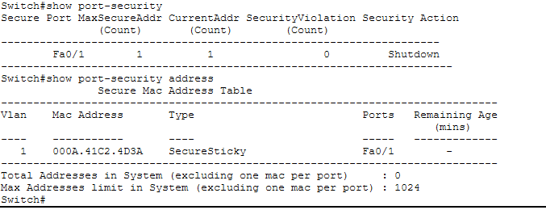
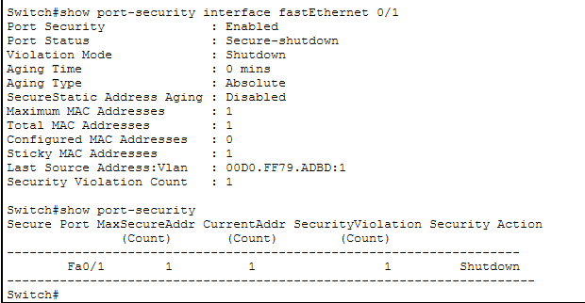

12. Create an Extended ACL to block specific applications, such as HTTP or FTP traffic. Test the ACL rules by attempting to access blocked services.

Devices Used
- 1 Router
- 2 Switches
- 1 PC
- 1 Server

Connections
- PC0 → Switch0
- Switch0 → Router0
- Router0 → Switch1
- Switch1 → Server0
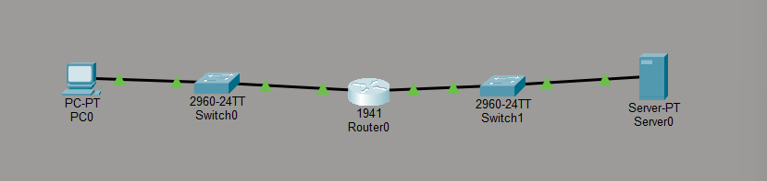

What is the process?
In this experiment:
- The PC acts as the client
- The Server provides HTTP and FTP services
- The Router is used to apply an Extended ACL
- The ACL is configured to block HTTP and FTP traffic
- At the same time, other traffic like ping is allowed

Main idea of the experiment
This experiment is done to show that:
- a user can be restricted from using specific applications
- such as:
  - HTTP (web access)
  - FTP (file transfer)
using an Extended Access Control List (ACL).

What you will test
After configuration:
- Ping from PC to Server should work
- HTTP from PC to Server should not work
- FTP from PC to Server should not work
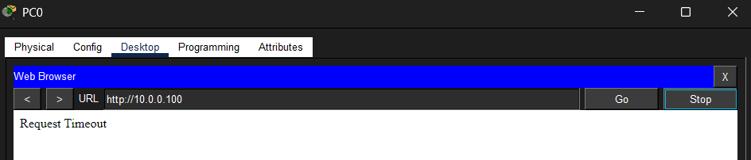
That proves the ACL is working correctly.

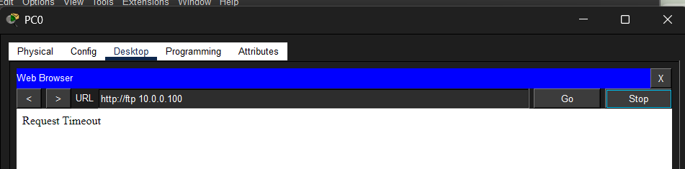

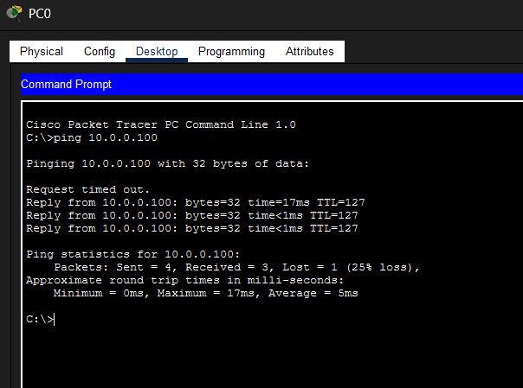
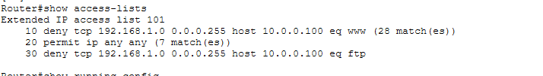

1) Static NAT Configuration

Router CLI Commands Used
enable
configure terminal
interface gigabitEthernet 0/0
ip address 192.168.1.1 255.255.255.0
ip nat inside
no shutdown
exit
interface gigabitEthernet 0/1
ip address 200.1.1.1 255.255.255.0
ip nat outside
no shutdown
exit
ip nat inside source static 192.168.1.10 200.1.1.10
end
write memory

Verification Command
show ip nat translations
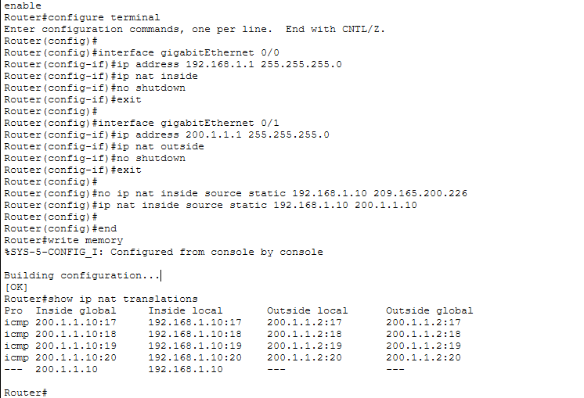

Result
Static NAT was configured successfully.
The private IP address 192.168.1.10 was translated to the public IP address 200.1.1.10.

2) Dynamic NAT Configuration

Router CLI Commands Used
configure terminal
access-list 1 permit 192.168.1.11
ip nat pool DYNPOOL 200.1.1.20 200.1.1.25 netmask 255.255.255.0
ip nat inside source list 1 pool DYNPOOL
end
write memory

Verification Command
show ip nat translations

Result
Dynamic NAT was configured successfully.
The private IP address 192.168.1.11 was translated dynamically to a public IP from the NAT pool, such as 200.1.1.20.
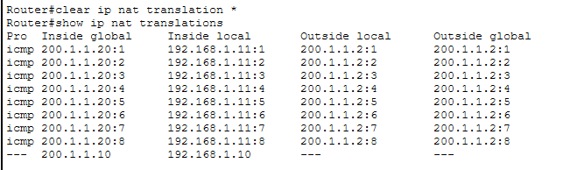

3) PAT Configuration

Router CLI Commands Used
configure terminal
no ip nat inside source list 1 pool DYNPOOL
ip nat inside source list 2 interface gigabitEthernet 0/1 overload
end
write memory

ACL Used for PAT
access-list 2 permit 192.168.1.0 0.0.0.255

Verification Command
show ip nat translations

Result
PAT was configured successfully.
Multiple private IP addresses were translated using the same public IP address 200.1.1.1 with different port / ICMP numbers.
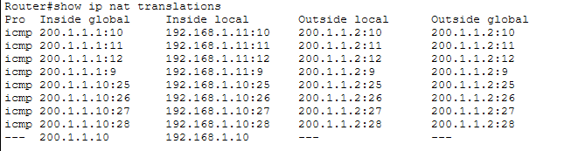

14.Download iPerf in laptop or phone and make sure they are in same network. Try different iPerf commands with TCP, UDP, bidirectional, reverse, multicast, parallel options and analyze the bandwidth and rate of transmission, delay, jitter, etc.
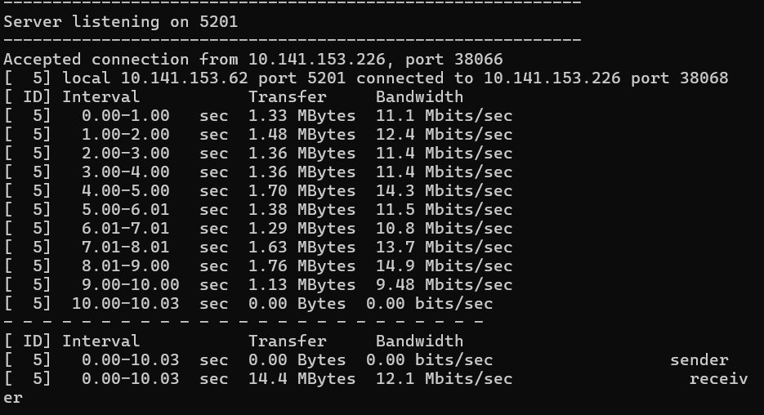
- Download and extract iPerf3 on the laptop.
- Open Command Prompt and navigate to the iPerf3 folder.
- Start the server using command:
iperf3 -s
- Ensure server is listening on default port 5201.
- Connect mobile and laptop to the same Wi-Fi network.
- Identify laptop IP address using ipconfig.
- Open iPerf3 mobile application.
- Enter server IP address and port number (5201).
- Select Upload test and start transmission.
- Observe connection establishment in command prompt.
- Note bandwidth and transfer values displayed.
- Perform Download test from mobile application.
- Record the results for both directions.
- Take screenshots of output for documentation.
- Analyze network performance parameters.
TCP command:
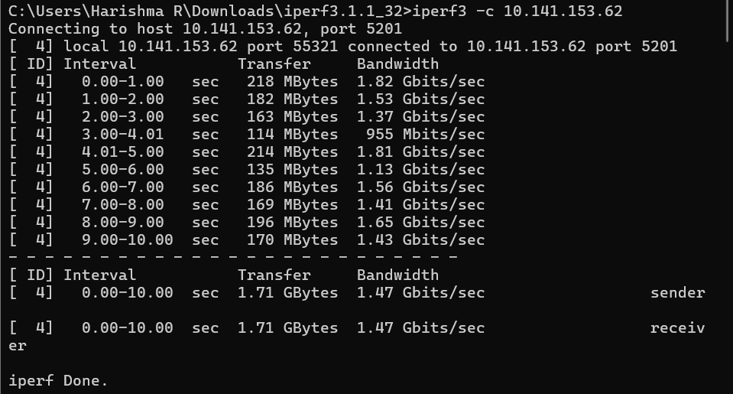

UDP command:
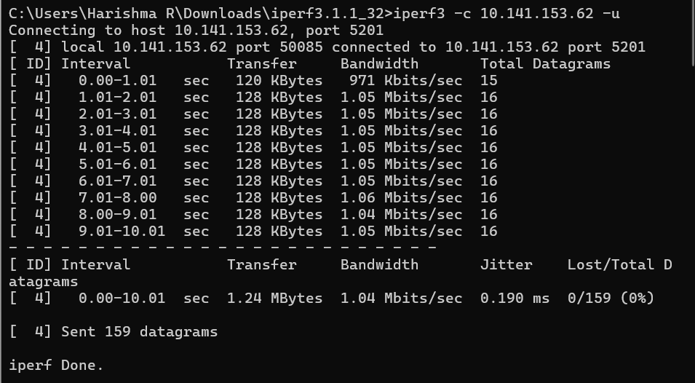

Reverse test
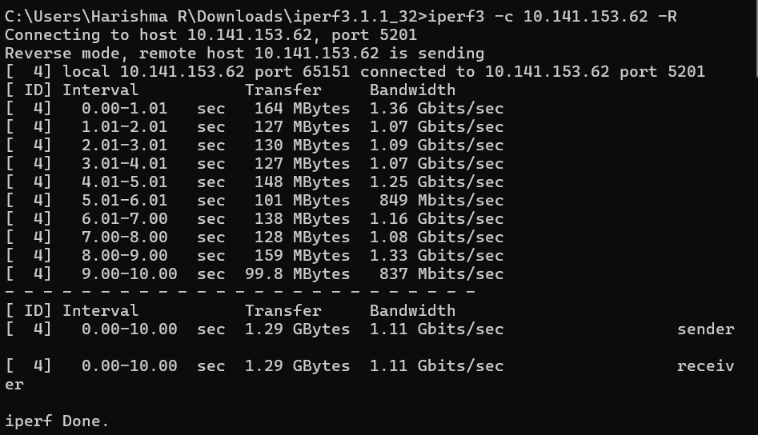
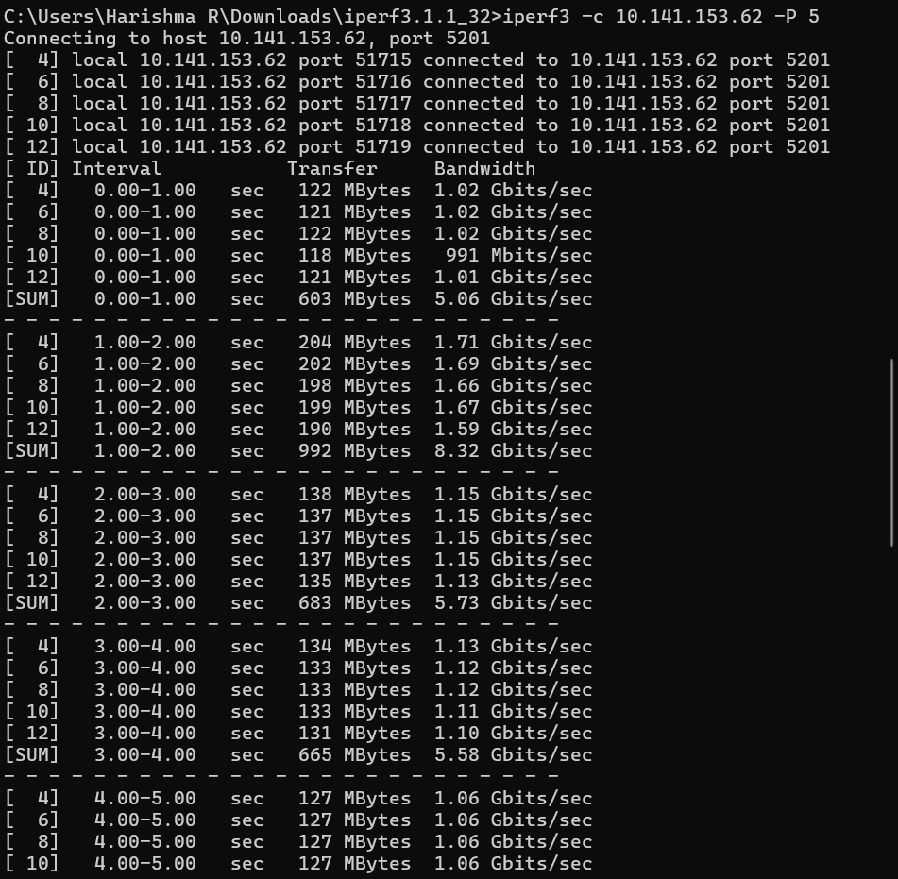
Parallel Streams
